6-1. 1
INTRODUCTION TO CHEMICAL BONDING (pg. 161)

1. Atoms seldom exist as independent…

2. A CHEMICAL BOND is a mutual electrical attraction between
the nuclei and valence electrons of different atoms that…

3. Most atoms are less stable existing by themselves than when
they are…

4. Chemically bonded atoms have a HIGHER / LOWER
potential energy.

TYPES OF CHEMICAL BONDING (pg. 161)
1. When atoms bond, their valence electrons are…

2. The way in which the electrons are redistributed determines…

3. Chemical bonding that results from the electrical attraction
between large numbers of cations and anions is called…

4. In purely ionic bonding, atoms completely give up there…

5. COVALENT BONDING results from the sharing of…

6. In a purely covalent bond, the shared electrons are "owned"…
6-1. 2
IONIC OR COVALENT? (pg. 161-162)
1. Bonding between atoms of different elements is never purely
ionic and is rarely…

2. Recall that electronegativity is a measure of an atom's ability…

3. The degree to which bonding between atoms of two elements is
ionic or covalent can be estimated by calculating the…

4. Bonding between atoms with an electronegativity difference
of 1.7 or less has an ionic character of 50% or less and is
classified as…

5. Bonding between two atoms of the same element is completely

6. A NONPOLAR COVALENT BOND, is a covalent bond in
which the bonding electrons are shared equally by the bonded
atoms, resulting in a balanced distribution of…

7. Bonds having 0 to 5% ionic character, corresponding to
electronegativity differences of roughly 0 to 0.3, are generally
considered…

8. POLAR BONDS have an uneven distribution of…

9. Covalent bonds having 5 to 50% ionic character, corresponding
to electronegativity differences of 0.3 to 1.7, are classified as…

10. A POLAR-COVALENT BOND is a covalent bond in which
the bonded atoms have an equal attraction for the…

11. In a polar covalent bond, the charged ends of the compound
are indicated by

- δ - =
- δ + =

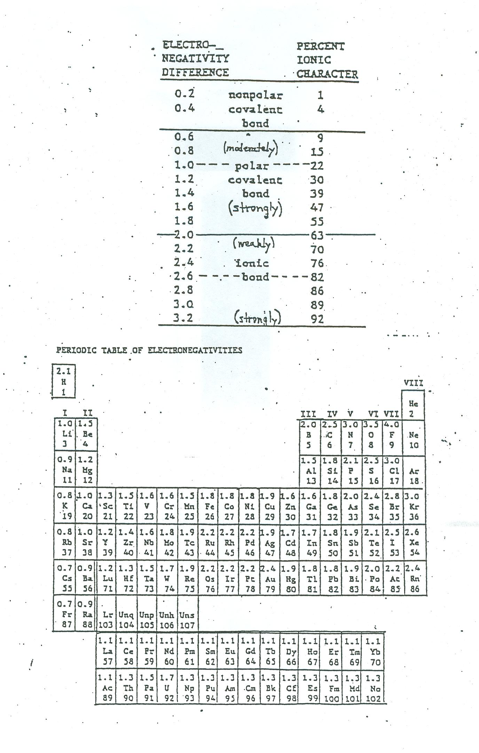
6-1.2A

- Determine the electonegativity difference, the probable bond type, and the more elecronegative atom with respect to bonds formed between the following pairs of atoms.

Elements  Bonded | Electronegativity Difference | Bond  Type | More  Electronegative Atom
H and I | 2.1 - 2.5 = 0.4 | Nonpolar-Covalent | I
S and O
K and Br
Si and Cl
H and F
Se and S
C and H
C and S
O and H
Na and Cl
Cs and S
Zn and O
Br and I
S and Cl

Cu and S

- Determine whether each of the following bonds would be polar, nonpolar, purely covalent or ionic:

a. _______________ H—H

b. _______________ N—O

c. _______________ H—F

d. _______________ Br—Br

e. _______________ H—Cl

f. _______________ H—N
g. _______________ K—Cl

h. ________________ O—O

i. _______________ H—H

j. ________________ Li—F

k. _______________ C—S

l. ________________ Ag—Au

6-2. 1

COVALENT BONDING AND MOLECULAR
COMPOUNDS (pg. 164)

1. A MOLECULE is a neutral group of atoms that are held
together by…

2. A single molecule of a chemical compound is an individual unit
capable of…

3. A chemical compound whose simplest units are molecules is
called a…

4. A CHEMICAL FORMULA indicates the relative numbers of
atoms of each kind in a chemical compound by using…

5. A MOLECULAR FORMULA shows the type and numbers of
atoms combined in a single molecule of a…

6. The molecular formula for water ( H₂O ) reflects the fact that a
single water molecule consists of oxygen atom joined by
separate covalent bonds to two…

7. A molecule of oxygen, ( O₂ ) is an example of a…

8. A DIATOMIC MOLECULE is a molecule containing only…

6-2. 2
FORMATION OF A COVALENT BOND (pg. 165)

1. Most atoms are at lower potential energy when bonded to other
atoms than they are at as...

2. The relative strength of attraction and repulsion between the
charged particles depends on the...

3. When atoms first see each other, the electron-proton attraction
is stronger than the electron-electron and proton-proton...

4. When the distance between atoms is reached where the
repulsion between the like charges equals the attraction of
opposite charges potential energy is at a minimum and a…

CHARACTERISTICS OF COVALENT BONDS (pg. 167-168)
1. The average distance between two bonded atoms is the...

2. BOND ENERGY is the energy required to break a chemical…

3. The units for bond energies are...

THE OCTET RULE WITH EXCEPTIONS (pg. 168-169)
1. The OCTET RULE states that chemical compounds tend to
form so that each atom, by gaining, losing, or sharing electrons,
has an octet of electrons in its...

2. Main-group elements tend to form covalent bonds according to
the octet rule but there are exceptions. In these cases bonding
involves electrons in...
6-3. 1

IONIC BONDING AND IONIC COMPOUNDS
(pg. 176)

1. Most of the rocks and minerals that make up the earth’s crust
consist of positive and negative ions held together by…

2. A familiar example of an ionically bonded compound is sodium
chloride also known as…

●____________________ ●____________________

3. The formula for sodium chloride is…

4. In an ionic bond, each positive charge is balance by a…

5. An IONIC COMPOUND is composed of positive and negative
ions that are combined so that the numbers of…

6. Most ionic compounds exist as…

7. The chemical formula of an ionic compound represents the
simplest ratio of the compound’s combined ions that gives…

8. The simplest collection of atoms from which an ionic
compound’s formula can be established is known as its…

9. The ratio of ions in a formula unit depends on the charges of the

10. The formula of calcium fluoride is…
6-3. 2

CHARACTERISTICS OF IONIC BONDS (pg.177-178)
1. Nature favors arrangements in which potential energy is…

2. In an ionic crystal, ions minimize their potential energy by
combining in an orderly arrangement known as…

3. LATTICE ENERGY is the energy released when one mole of
an ionic crystalline compound is…

IONIC & MOLECULAR COMPOUNDS (pg. 179)
1. The forces of attraction between molecular compounds are
much weaker than the forces in…

2. The melting point, boiling point, and hardness of a compound
depend on how strongly its basic units are…

3. Ionic compounds generally have…

4. The attraction between positive and negative ions in a
crystalline ionic compound causes layers of ions to…

5. When struck with sufficient force, the layers shift so that ions of
the same charge approach each other, causing repulsion which...

6. In the molten state, or when dissolved in water, ionic
compounds are…

POLYATOMIC IONS (pg. 180)
1. A charged group of covalently bonded atoms is known as a…

2. The charge of a polyatomic ion results from an excess of…
6-4.1
METALLIC BONDING (pg. 181)
1. Chemical bonding is different in metals than it is in…

2. Metals are excellent…

3. This property is due to the highly mobile…

THE METALLIC-BOND MODEL (pg. 181)
1. The highest energy levels of most metal atoms are occupied by

2. A metals vacant orbital in the atoms' outer energy levels…

3. The outer electrons are delocalized. They do not belong to any
one atom but move about the metal's network of…

4. These mobile electrons form a…

5. The chemical bonding that results from the attraction between
metal atoms and the surrounding sea of electrons is called…

METALLIC PROPERTIES (pg. 181-182)
1. The freedom of motion of electrons in a network of metal atoms
accounts for the high electrical and thermal conductivity
characteristic of…

2. The shiny appearance of metal surfaces is caused by the de-
excitation of excited electrons immediately falling back down
to a lower energy level emitting energy in the form of…

3. Most metals are also easy to form into…

4. MALLEABILITY is the ability of a substance to be hammered
or beaten into…

5. DUCTILTIY is the ability of a substance to be drawn, pulled, or
extruded through a small opening to produce a…
6-4.2
TYPES OF CHEMICAL BONDS

- Classify the following compounds as ionic (metal + nonmetal), covalent (nonmetal + nonmetal), metallic (metal + metal) or both (compound containing a polyatomic ion).

1. ____________ CaCl₂

2. ____________ CO₂

3. ____________ H₂O

4. ____________ BaSO₄

5. ____________ K₂O

6. ____________ NaF

7. ____________ Na₂CO₃

8. ____________ CH₄

9. ____________ SO₃

10.____________ LiBr

11. ____________ MgO

12. ____________ NH₄Cl

13.____________ HCl

14.____________ KI

15.____________ Na

16.____________ NO₂

17.____________ AlPO₄

18.____________ Au

19.____________ P₂O₅

20.____________ N₂O₃

21.____________ NaOH

22.____________ N₂

23.____________ H₂SO₄

24.____________ FeCl₃

25.____________ ZnCu

26.____________ S₈

6-4.3

Exp. 6-4: Physical Properties and Chemical Bonding in Solids

Purpose: To investigate some physical properties of solids containing ionic, covalent, molecular and metallic bonds to learn how to discriminate among them on the basis of properties correlated with their bonding forces. These properties will also allow you to determine the type of bonding in an unknown solid.

Introduction
To a large extent, the physical properties of a solid substance are determined by the type of bonding which holds the molecules, atoms or ions together. Solids may be classified as ionic, molecular, metallic or covalent network solids.

Ionic solids have ions located at regular, repeating crystal lattice sites with bonding among ions being primarily electrostatic. This type of bonding is essentially nondirectional; ions arrange themselves in sites to form a crystal structure that maximizes attractions and minimizes repulsion. The electrostatic forces are strong, giving rise to large lattice energies—it takes a large quantity of energy to disrupt the crystal.

By contrast, covalent molecular solids have molecules held in place in a crystal lattice either by weak dispersion forces or dipole—dipole forces. These forces allow the crystal to be disrupted with a much smaller energy input than is the case for ionic solids.

Bonding in metals is quite different from that of other classes. Metallic bonding is electrostatic as in ionic solids, but the attraction is between valence electrons and the positively—charged metal atoms. This creates nondirectional bonding; electrons are not strongly associated with any one particular atom. Thus the electrons are rather mobile, accounting for the properties of metals.

For a substance to conduct an electrical current, the substance must posses free-moving charged particles. These charged particles may be delocalized electrons, such as those found in substances that form metallic bonds. The particles may also be mobile ions, such as those found in dissolved in salts, or they may be ions formed by certain molecular substances having polar-covalent bonds that dissociate when dissolved in water. The fact that a substance is a conductor in it's pure form, or only in solution defines a physical property of the substance and provides clues about the inner structure and type of bonding found in the substance.

Exp. 6-4 Procedure

- Part A: Melting Point

1. Place a tin can on an iron ring attached to a ring stand. Position the tin can
so it’s just above the tip of the burner flame, as shown in Figure A.

2. Place pea—sized samples of sodium chloride (NaCl), iron filings (Fe), zinc
chloride (ZnCl), Sucrose (C₁₂H₂₂O₁₁), unknown #1 and unknown #2 in
separate locations on the tin can as shown in Figure B. Do not allow the
samples of crystals to touch each other.

3. Light the burner so that there is no air burning, only methane gas, by closing
the barrel of the burner (USE THE EHHAUST TRUNK TO CATCH
THE SMOKE WHILE HEATING). Record the order of melting for the
substances. After 2 minutes, record an "No" in your data table for each
substance that did not melt. Extinguish the flame. Allow the tin can to cool
while you complete the remainder of the experiment. When cool clean off
the can and place it back on the bench.

- Part B: Solubility

1. Arrange a test tube rack with six pairs of test tubes. Add pea—sized
sample of NaCl to each test tube in the first pair. Do likewise with the other
solids in the remaining five pairs of test tubes. Add 5 mL of DI water to the
first of each pair of test tubes. Add 5 mL of ethanol (CAUTION:
ETHANOL IS EXTREEMELY FLAMABLE, KEEP AWAY FROM
FLAMES) to the second of each pair of test tubes. Shake the test tubes
noting any evidence of dissolving of the solid recording your observations in
data table.

- Part C: Conductivity

1. Test your conductivity apparatus to make sure it lights up when the two wire
leads are touched together. When the two leads on the tester touch each
other, the light should automatically go on.

2. Pour 5 mL of DI water and 5 mL of ethanol onto two different evaporating
glasses and test the liquids for conductivity by placing the wire leads in
good contact with the liquid. Note whether or not it conducts, as indicated
by the light on the conductivity tester and record your results in data table.

3. Pour the contents of each pair of test tubes (one with water and the other
with ethanol along with the samples) onto two different evaporating glasses
and test the solution for conductivity as in step 1 above and record your
results.

4. Place the wire leads in good contact with solid samples. Note whether or
not it conducts and record your results in data table.
Name____________________ Date__________ Partner____________________

Exp. 6-4: Physical Properties and Chemical Bonding in Solids

Data Table
Compound | Description | Order of Melting | Solubility In  Water EtOH |  |  | Conductivity  In Water EtOH |  |  | Solid Cond | Bond Type
Sodium Chloride
Zinc Chloride
Iron Filings
Sucrose
Unknown # 1
Unknown # 2

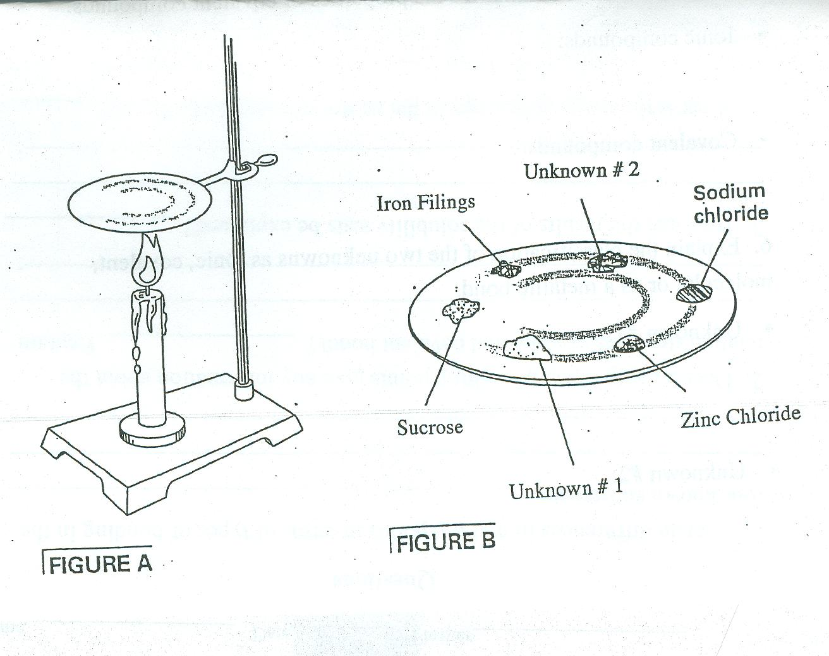

Questions/Conclusions

1. Explain differences in melting points in terms of types of bonding in the
four known substances._______________________________________

__________________________________________________________

__________________________________________________________.

2. Does a comparison of melting points give any information about the
relative strengths of ionic and covalent bonds? ____________________

Explain____________________________________________________

__________________________________________________________

3. How can the results of the solubility tests be explained? ______________

___________________________________________________________

__________________________________________________________.

4. What is the major difference in the nature of water and ethanol? ______

__________________________________________________________.

5. Write a statement to summarize the properties of ionic compounds and
another statement to summarize the properties of covalent compounds.

- Ionic compounds:

- Covalent compounds:

6. Explain the classification of the two unknowns as ionic, covalent,
molecular or as a metallic bond.

- Unknown #1:

- Unknown #2:
Chapter 6.1—6.4
 |  |  |  | Covalent
 | Ionic | Pure |  |  | Polar | Non-Polar |  |  | Metallic
Types of Atoms

Electrons

Strength

Covalent
Examples
Pure

Polar

Non-Polar

