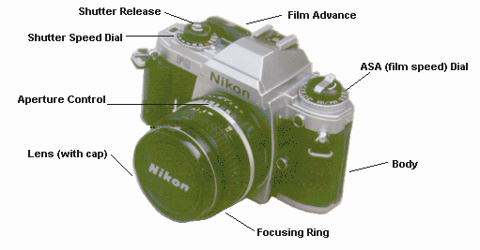

Exposure Controls
When you take a picture, you "expose" the film to light. The two parts which work together to control your exposure are the APERTURE and SHUTTER.
APERTURE
The aperture is an opening that changes in size to admit more or less light (similar to the iris of an eye). The numbers on the aperture control are called F-stops and referred to as F16, F11, F8, and so on. The aperture control may look something like this:

Here's how it works:
The larger the F-stop number, the smaller the opening.
Each number higher lets in half as much light as one number lower.
For example, F5.6 admits twice as much light as F8, while F11 lets in only half as much.
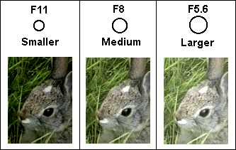
The aperture doesn't work alone, however. The shutter speed is responsible for exposure, too. It controls the amount of time light is allowed to reach the film.

SHUTTER
The shutter is a device that opens and closes at varying speeds to determine the amount of time the light entering the aperture is allowed to reach the film.
Shutter speed is measured in fractions of a second. 125 means 1/125 of a second, 60 means 1/60. Typical shutter speeds range from 1 second to 1/1000. A shutter speed setting for a bright, sunny day - using an aperture of F11 - might be 1/125 second. A cloudy day might use 1/60 second with the same aperture, exposing the film to light for a longer period of time.
The settings for a good exposure are determined by a light meter. (Most 35mm cameras have a built-in light meter that shows you the appropriate settings, or automatically controls them.)
Aperture and shutter settings work together. Because the shutter (like the aperture) approximately halves or doubles the light reaching the film with each change in setting, a number of different combinations of settings can result in the same exposure.
Aperture | F22 | F16 | F11 | F8 | F5.6
Shutter | 1/30 | 1/60 | 1/125 | 1/250 | 1/500

Any of the combinations shown above would result in approximately the same exposure.
If all the settings result in the same exposure, why would you want to use F5.6 at 1/125 instead of F11 at 1/30? Two good reasons: By selecting the right combination for the situation you can control depth of field and motion blur.

the area or 'zone' of a photograph,
from front to back,
which is in focus
Little depth of field
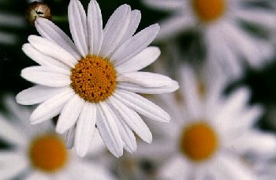

Greater depth of field
More sharp detail is visible.
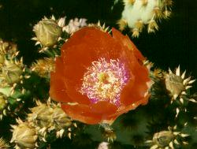 | 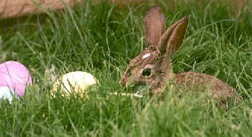

Three factors can affect the depth of field:
- focal length of the lens
- distance from the camera to the subject
- the size of the aperture or the setting of the f-stop

I. Focal length of the lens
The depth of field is inversely proportional to the focal length of the lens; that is, the smaller the focal length number of the lens, the greater the depth of field. For example, a 28mm lens has the ability to capture more of the picture in sharp focus than a 100mm lens.
II. Distance from the camera to the subject
Depth of field is directly proportional to distance; i.e. a subject at a greater distance will have greater depth of field than a close-up subject. Therefore, you need not worry as much about a distant subject being out of focus.
III. The size of the aperture or (f-stop)
While changing the aperture (f-stop) will not have a striking effect on the depth of field for a distant subject or a wide angle (short focal length) lens, it can make a great deal of difference in a close-up or a photo taken using a telephoto or zoom lens.
A wider aperture (smaller f-stop number) will result in a shallower depth of field. You can use this to keep either the foreground or background out of focus while maintaining the subject in focus. When changing the aperture setting, you will need to also adjust the shutter to maintain the correct exposure.
Aperture = F5.6  Shutter = 1/1000  Little/Shallow depth of field | Aperture = F22  Shutter = 1/60  Greater/More depth of field
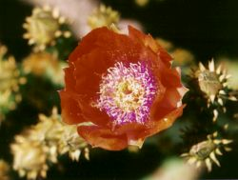

While most photographers take the above factors into account and make adjustments based on experience, or bracket their exposures, it is possible to calculate depth of field using mathematical formulas

Motion Blur
- the term used to describe the blurred effect in a photograph caused by movement of either the subject or the camera.

example - bird in flight
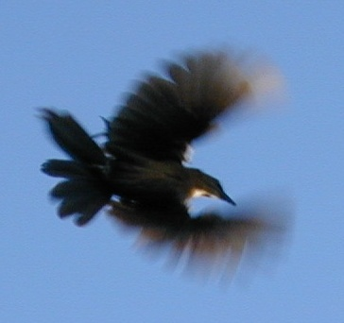
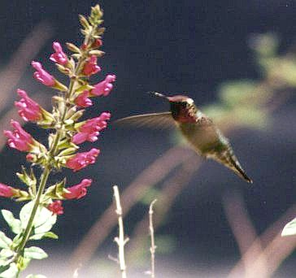

Usually, you would want to avoid this effect by using shutter speeds of 1/125 or faster. Certain subjects, however, are most effectively photographed by deliberately capturing the blur.
Sports photographers frequently make use of blur to emphasize the speed or direction of movement.
There are two popular methods for doing this.
- Subject blur - hold the camera steady while the subject moves
- Background blur - move (pan or tilt) the camera with the subject.
People in action generally require a slower than average shutter speed (1/50th of a second or longer.) High speed subjects such as a race car or a roadrunner moving across the camera view, may blur at 1/500.
If possible, you will want to bracket your shots, because the subject may move faster or slower than you anticipate.
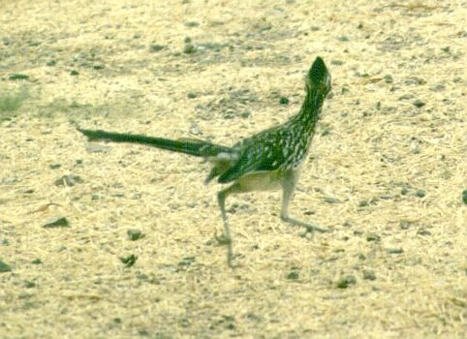
When adjusting to a slower shutter speed, you will also be allowing more light to reach the film for a longer period of time. In order to avoid overexposure, you will need to use a smaller aperture (larger f-stop number).

In order for an image to be captured on film, it must be exposed to light. In photography, it is important to be able to measure light. Too much light can ruin a photograph, and so can too little. Light can be measured and controlled by it's brightness- (F-Stops) and by it's duration-(Shutter Speed).

Film reacts to light. The more light you give to it, the brighter the image will be. You can buy all types of film for your camera, and they will all have a FILM SPEED. "Fast" films are more sensitive to light than "slow" films.

Cameras come in all shapes and sizes. Three things all cameras have in common are a lens, an aperture, and a shutter. By adjusting the aperture-( F-Stop ) and shutter settings, you change the way light and film interact.
A Shutter :
In a camera, the shutter blocks all light from exposing the film UNTIL you press the button.Then it quickly opens and closes, giving the film a brief flash of light. You can control the length of time the shutter remains open by setting the SHUTTER SPEED.
An Aperture :
When light passes through a camera's lens, it must pass through an opening called an "Aperture". In plain english it's a hole that lets in more light when it's wide open and less when it's small. Figures, huh? In essence the aperture is just like the pupil in the human eye. You can control the aperture by setting the "Aperture Opening", also known as an F-Stop.

Shutter speed
Determines HOW LONG the shutter stays open.
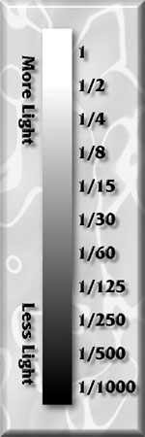
E x a m p l e s
A half second exposure is ONE STOP darker than a one second exposure.
A 1/125 exposure is TWO STOPS brighter than a 1/500 exposure.
A 1/1000 exposure is THREE STOPS darker than a 1/125 exposure.
The longer exposures ( like 1 second ) give much MORE light to the film than a 1/1000 of a second exposure. So even though the number may look bigger, don't be decieved!

F-Stops :
Control how much light is passed through the lens.
Every step in this table represents a ONE STOP change in light.
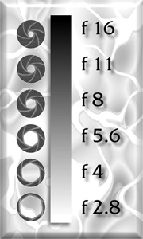
Like the pupil in a human eye, the aperture on a camera controls light. It does so by closing up to restrict light, and opening up to let it through. Lower F-Stop numbers indicate MORE LIGHT.

Okay, so now you know all about the shutter and the aperture. Exposure is about different combinations of shutter and f-stop settings. These combinations can drastically affect the finished picture. For example, the following three pictures have been given an equal amount of light, but the f-stop and shutter combinations make each one unique.
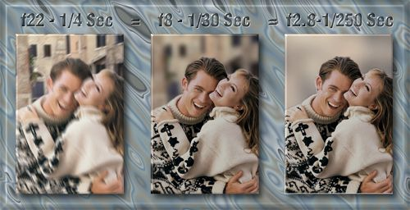
Why is the backround all blurred in the right picture, and sharpest in the left ? Because if the exposure is made with a wide aperture ( like f2.8 ), then objects farther away from the subject are thrown farther out of focus.
So... if the aperture is small (like f22) then objects in the backround (and foreground ) will appear sharper. However, since more light was required to make the exposure on the left ( 1/4 Second ) in this example the subjects became blurred from MOTION.
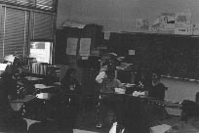
DARK PHOTO -This photo was probably made from an underexposed negative which was too thin or clear to make a good print. The bright window in the left corner of the room was likely responsible for the light meter thinking there was more light leading to setting the exposure to let in less light than was needed for the majority of the class setting. Little can be done to fix this after film processing. There is an intensifier chemical in the lab that helps a little, but the best solution is to redo the assignment. If the print MUST be made for yearbook or photojournalism then cut the enlarger light way back and do an ACCURATE test strip with processing in fresh developer for a full 90 seconds to get the best possible exposure.
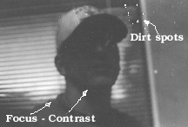
DIRT - CONTRAST - FOCUS - just about all you can do to mess up a print is here. It started with the bright background again causing the film to be thin. Film was not developed long enough which reduced contrast in the film leading to a LOW contrast print. Dirt spots are common in our old darkroom and require CAREFUL cleaning of the room and film before printing. Focus of the enlarger was also messed up on this photo.

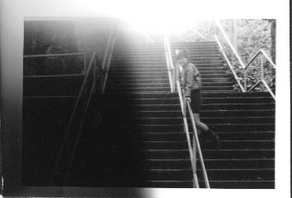
FOG - This happens a lot in a large darkroom. Students MUST keep their photo paper inside their paper packet with BOTH bags closed. Paper that is left out on the counter top or paper packets that have the flap left open will be struck by light like this causing FOG. The clue is the white boarder which should be clean white on good paper.

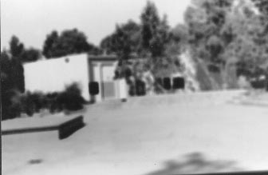
FOCUS ERROR - This should not happen, but is another of the most common errors in our lab. The enlarger just was NOT in focus. To focus, be sure the enlarger is set to full brightness, then turn the focus knob up and down looking at the middle tones of gray to see when they get the sharpest. Then, turn the light down three or 4 clicks of the lens to darken the exposure and increase the sharpness of the enlarger.

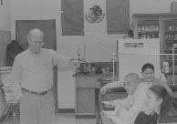
LOW CONTRAST - this probably started with a poorly processed roll of film. Contrast is effected by how long film is developed or by agitation of the film. In the print process contrast can be lost with an overexposed print that is yanked from the developer before the full 90 seconds is up. Lack of patience! To get good contrast a good test strip MUST be made with processing of 60 to 90 seconds in fresh developer with CONSTANT agitation
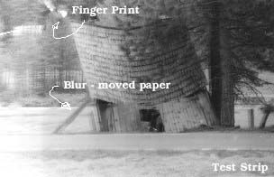
.
This print is actually a test strip that was moved during printing. Moved enlargers, film or easels can blur a photo. There also is a large finger print in the upper left that comes from wet hands handling paper and touching the emulsion before exposure. Clean and dry hands and handling from the edge help cure this and as for the motion - be careful not to bump the enlarger or easel during exposure of the print.

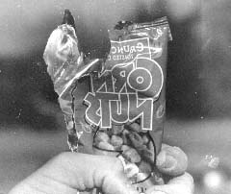
BACKWARDS NEGATIVE - This is also a common mistake for new photo students. The film MUST go into the negative holder in the enlarger shinny side face UP or another way of saying that is DULL side DOWN (DD). This print may look fine, but the writing is backwards, a real clue things are backwards. There is also a minor problem with dust and a finger print in the lower right corner.

CARE is the answer to most all of these problems listed on this page. Care to pay attention to the details. Care to have the patience to do ALL of the things shown in class and not eliminating some to speed up the process. Care in keeping the lab clean and care in taking care of your supplies and negatives are all part of making a show quality print and being proud of our work.

Developing roll Film
In order to produce a properly developed negative in a daylight tank, the temperature and duration of the process must be carefully regulated. Generally, a temperature of 68 degrees F (20 degrees C) is recommended for black-and-white film developers and other processing solutions. Depending on the film and developer combination, recommended developing times may vary from a few to several minutes. Photographers often use a timer with a bell or buzzer at this stage.
During development the solution is periodically agitated--gently sloshed around--to ensure uniform development and to prevent streaks from forming on the film. Experienced photographers usually agitate on the same time schedule for every roll of film the process.
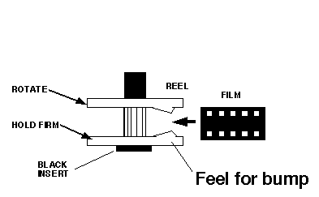

In a darkroom or changing bag where you have placed a film tank, reel, center insert and scissors remove the cap from the flat end of our roll film cartridge. Remove the inner reel and trim the film leader off of the film. Handle the film only by the edges or better yet use cotton gloves to avoid finger prints on the film surface.
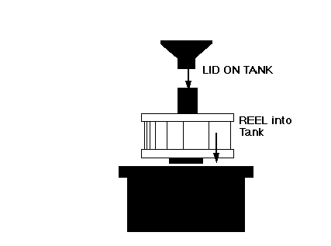
In the DARK, place the tank reel so that the insert faces away from you. Feel for the bumps on the inner side of the reel. That is the start of the reel spiral that will hold the film Insert the flat end of the film into the spiral and pull it about half way around the reel. Then twist the top reel while holding the bottom reel still. This will push the film into the reel. Keep this up until the end of the roll is reached. Cut the tape and plastic reel off and you are done.
Place the reel into the tank with the plastic insert face up. Notice that the lid on the tank fits into the center of the insert. Place the lid on the tank and twist it clock wise until it clicks shut.
You are now free to bring the tank out of the dark for processing.

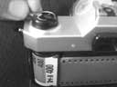
Loading Film in Camera
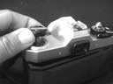
The steps shown here are for loading the Pentax K1000 camera used at SCHS. The K1000 is the lowest cost manual camera on the market. It was discontinued in 1998 and will slowly be replaced by a Kalimar K-90 which looks almost identical. Follow all of these steps exactly and be aware of warnings that will save you sorrow later.
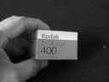
(1) Pull UP on the rewind knob on the left side of the camera. This will open up the back of the camera as you see in this photograph. Be sure you pull up far enough. If the back does not open it means you did not pull up far enough.
(2) The film that we will use in this class is called TRI-X and is made by Kodak. Be sure you have a 24 exposure box and not a 36 exposure roll. The 36 will work, but it is harder to take all of the pictures in one class period and it is VERY hard to load onto the film container for processing. Open up the box, take out the plastic container (keep this for storage) and remove the roll of film with the leader sticking out.
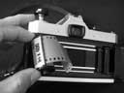
(4) Place the film into the left side of the camera. IF the film does not slip easily into the open area pull UP on the rewind knob again to make space for the film. Push the rewind knob back after the film is in the pocket. IF it does not go all the way in twist it until it seats into the film container all the way. The leader is pulled to the other side of the camera and is ready to place in the take up spool. On an auto load camera simply pull the leader until it reaches the red dot and then seat the film holes on the little teeth in the take up mechanism.
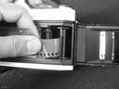
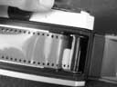
(5) Insert the narrow end of the film leader into the take up spool slot or opening. It will go in a short distance and then STOP. It has hit a spring like mechanism that it must be PUSHED past. Hold the spool steady with one hand and PUSH the film in deeper until it either goes all the way inside the spool or it comes out the other side. This is the most common error. IF it is not in far enough it will pop off when taking pictures and you will get nothing on your film and waste the $3 it cost you.
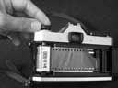
(6) Push the shutter release if needed and then use the film advance to wind the film until the entire leader is wound around the take up spool like you see here. Let the camera do the winding for it will do it backwards from what seems logical. Make sure the teeth are properly placed in the holes on the film on BOTH sides of the film. Next use the rewind knob to take up the slack - to tighten the film in the camera. Turn the knob in the direction of the arrow until the film slack is taken up. Do not pull so hard that you tear the film or begin to pull it off the take up spool.

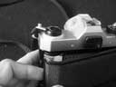
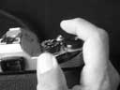
(7) Close the back of the camera and immediately take THREE pictures. IF the film has been loaded properly the rewind knob will TURN every time you crank the film advance lever. IF it does not then check to be sure the slack was taken up. If it was and the knob still does not turn then open up the back of the camera and check to be sure the film did not pop out of the take up spool. The film advance lever is on the right side of the camera and will not advance the film until the shutter has been released. Be sure to take at least 2 pictures. This will remove the exposed film from the leader and put fresh film in front of the shutter ready for your first photo.
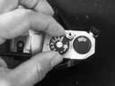
(8) Set the ASA or ISO number on the shutter speed dial to 400 for our Tri-x film. This number will be different for each type of film. Next set the shutter speed to 1000 if it is a nice sunny day or 250 if it is overcast. This will be close to our needed shutter speed and will make exposure easier.
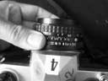
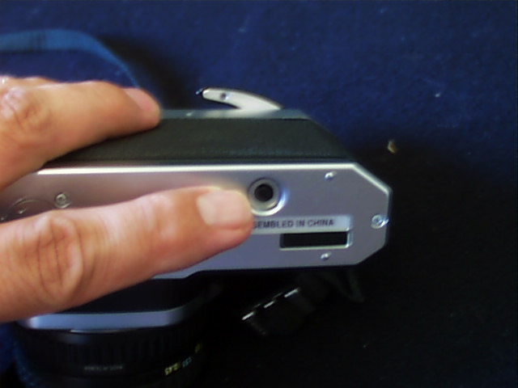
(9) Set the aperture on the ring closest to body of the camera (on the lens - it has numbers like 2, 4, 5.6, 8, 11 and 16) to an aperture of f16. This will let in the least light and is a good starting point for setting up exposure.
When you are finished taking pictures DO NOT open up the back of the camera until you have rewound the film back into the cartridge. To rewind the film you first MUST release the film by pushing the little button on the bottom of the camera. Pushing this in allows the film take up spool to go backwards. Failure to do this will cause the film to rip and be destroyed. Once the button is in you may turn the rewind knob in the direction of the arrow. There will be roughly 26 complete turns for a roll of film. When the film is back into the cartridge you will hear a clicking sound and the rewind will get easier to turn. Then you may open up the back and pull out the film. Put the film in the storage container that was in the original box. If you do not it will leak light into the opening and fog your film (turn it black). Always load and unload a camera in shade and never in direct sun for it will also cause light leaks and fog your film.

EVERY camera has these basic parts.
We begin with a light tight BOX to hold the film and carry it around from subject to subject.
This first and main part is called the body.
The second part is the shutter which might be located in the lens (leaf shutter) or it might be located right in front of the film (focal plane shutter).
The shutter controls WHEN the light enters the camera and for how long it enters. The shutter in the lens is often faster and quieter, but makes changing the lens difficult. The shutter in front of the film allows for easy lens removal, but is often loud and slow. A good camera will have some way of adjusting the time the shutter is open plus there has to be some type of release for the shutter.
The lens lets in light. The larger the lens the more light. The lens also effects how large the image appears based on the focal length of the lens. The aperture is located in the lens and is a set of leaf like piece of metal that can change the size of the hole that lets in light. We consider the lens to be part of the shutter as we do not actually need a lens to focus an image if we have a small enough hole to let in the light.
Finally, we have the third part is film holder inside the camera. This must have some attachment that allows for the film to be moved which can either be a lever or a motor.

Shutter
Controls how LONG light enters the camera. This is TIMED by the shutter speed dial, usually on top of the camera. The larger the number the SHORTER the time. A short time lets in light quickly which will stop the MOTION an object might have as it travels across the film while being exposed.

Shutter Speeds on the common camera
1000 - 500 - 250 - 125 - 60 - 30 - 15 - 8 - 4 - 2 - 1 - B
Each speed is a fraction of a second - like 1/1000th of a second or 1/4 of a second. B stands for bulb and holds the shutter open as long as the shutter release is held down. This used to be attached to a long hose to a bulb held in the photographers hand, thus the name Bulb. Each shutter speed lets in half as much light at the none below it to allow for easier exposure calculations. There are two types of shutters. One is an opening in the camera lens and the other is a curtain, usually cloth or rubber, that moves accross the front of the film. The later is called a focal plain shutter. The Pentax K1000 we use in class uses a rubber curtain.

Aperture
The aperture controls how MUCH light enters the camera. This opening is inside the LENS of the camera and is adjusted by a ring on the outside of the lens. The larger the opening the less sharp the final image will be, much like in our original pinhole camera. The larger the opening the more light that is allowed into the camera.

Apertures on the common camera
1.4 - 2 - 4 - 5.6 - 8 - 11 - 16 - 22 - 32
Each of these represents a fraction again, thus 2 is 1/2 and 22 is 1/22 representing the basic size of the opening in relation to the focal length of the lens. An aperture of f2 on a telephoto lets in the same amount of light as on a 200 mm telephoto, yet the size of the opening will not be identical.
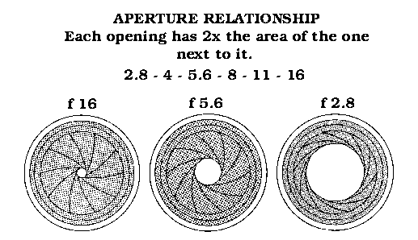

Viewfinders
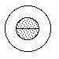
This is the opening in the back of the camera through which the photographer looks to aim the camera. A simple Viewfinder only camera will simply see a small image, much like what the camera will see. In a Reflex camera where actual light from a lens on the camera is being viewed on a piece of ground glass a focus aid may be seen like the one at the left. This is typical of a 35mm camera viewfinder. The space between the outer circle and the center circle will have a fuzzy, textured look when the photo is out of focus. As the image sharpens the two circles blend into the background. The center circle is a RANGE FINDER type focus. Here the image is cut in half. When the image in the top half aligns with the image in the bottom half the image is in focus. The rangefinder type of focus aid works better under low light conditions.

Film Advance
Though this is not really a camera control it still is an important part of the camera. Located on the body of the camera this is usually a lever at the top right corner in the cluster of controls that usually includes shutter speed dial, shutter release, counter and film advance. On some cameras the film advance is fully automatic using an electric motor. Often this film advance lever does more than just advance the film. On some cameras this lever when pulled out part way turns on the light meter. The film advance usually is part of the mechanism that cocks the shutter by pulling the curtain back to the right side of the camera. This same turning of the lever also advances the film counter in most cameras.

