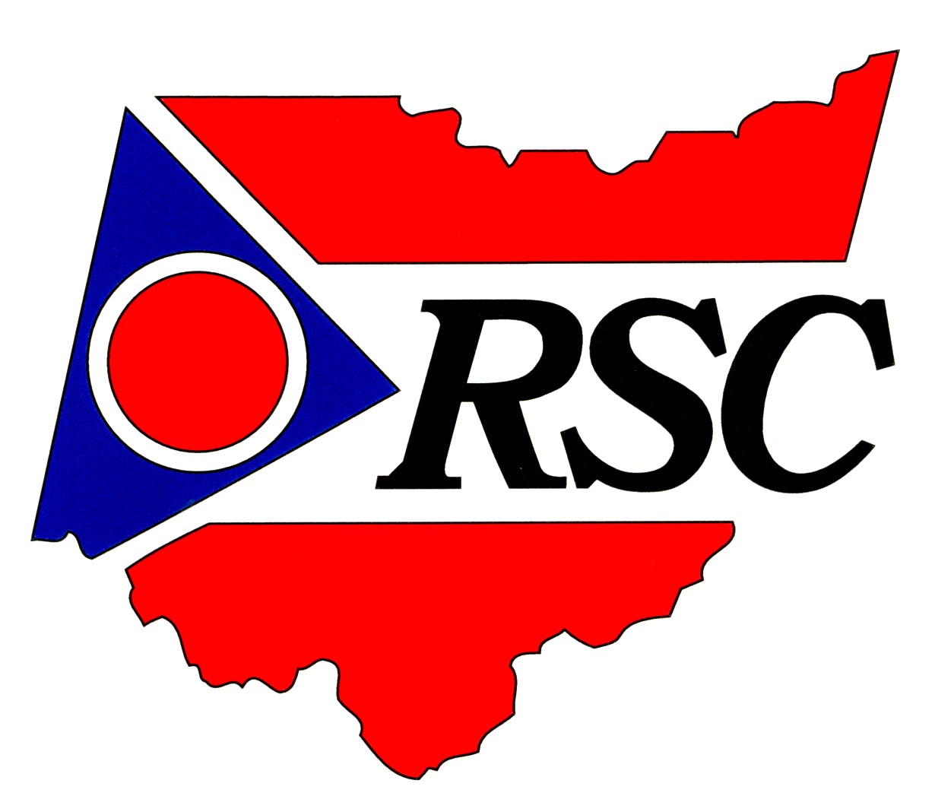

Consumer Guide to
Postsecondary
Educational Training

The Ohio Rehabilitation

Services Commission

The Ohio Rehabilitation Services Commission assists Ohioans with disabilities in getting the training or postsecondary education they need to participate in the workforce.
When you receive assistance from the Ohio Rehabilitation Services Commission (RSC), you will prepare an individualized plan for employment (IPE). At that time, you and your professional RSC counselor will work together to identify services that will help you select a successful career path consistent with your strengths, resources, priorities, concerns, abilities, capabilities and interests.
Because you are interested in postsecondary educational training to reach your career goal, RSC has given you this Consumer Guide to Postsecondary Educational Training booklet to explain related policies.
As a state agency, RSC is required to follow state policies pertaining to the purchase of goods and services, which includes educational programs. This guide will help you better understand these policies and requirements when you seek postsecondary educational training services. If you have questions after reading the guide, please discuss them with your counselor.
Postsecondary educational training may be provided at universities, colleges, community/junior colleges, career technical centers, technical institutes, schools of nursing, rehabilitation facilities, and other appropriate training sites or programs. Educational expenses include tuition, fees, books and supplies.
RSC'S POSTSECONDARY EDUCATIONAL TRAINING POLICIES

RSC’s Least-cost Principle

When RSC provides postsecondary educational training, “least cost” is the method it uses to determine options consistent with those required to reach your career goal. The determination of least cost for college training must include consideration of enrollment in an appropriate Ohio two-year college/educational institution, if it offers the coursework you need to meet your vocational rehabilitation (VR) goal. You may choose to attend any postsecondary institution; however, RSC will only pay at the level of the least cost institution.
After your freshman and sophomore years of postsecondary education
Once you have completed your freshman and sophomore years, RSC will pay for the remaining years of education at the cost level of the least cost four-year, postsecondary educational institution, after deducting from the educational expenses your “expected family contribution” (EFC) and any comparable benefits for which you qualify. These include the federal Pell Grant, Ohio College Opportunity Grant, Supplemental Educational Opportunity Grant, and Ohio Choice Grant.

Grades
To continue to receive RSC funding as an undergraduate student, you must maintain a cumulative “C” average (or equivalent). If you are a graduate or professional student, the standard will be the school’s grade requirement for graduation. If you are a student in any other training program, you must maintain the grade standard established by the program.
Duration
You have a maximum of eighteen (18) consecutive months to complete each academic year of postsecondary educational training as defined by the degree program. To extend the time limit on your IPE, the appropriate RSC area manager and/or designated assistant area manager shall request (with justification) approval from the RSC bureau director or designee.
Training supplies and equipment
RSC will provide training supplies and equipment only when the training program requires them for all trainees, or when you need them to overcome limitations imposed by a disability. Any training tools and equipment that RSC helps you pay for will remain RSC’s property until released to you in writing.
Applying for financial aid
If your school participates in Federal Student Aid programs, you must apply for financial aid by completing and submitting the Free Application for Federal Student Aid (FAFSA). The annual FAFSA deadline is Feb. 1 of each year or the deadline established by the educational institution. When completing the application, it is acceptable to use an estimated income tax if final tax forms won’t be available by Feb. 1 or the deadline.
Scholarships and other assistance
Besides the resources referenced in this guide, your RSC counselor will share a list of potential scholarships and other assistance. If you receive Supplemental Security Income (SSI) or Social Security Disability Insurance (SSDI), or if you are an injured worker who will receive services under RSC’s agreement with the Bureau of Workers’ Compensation, you are provided with postsecondary educational training without consideration of your expected family contribution. However, you must submit the FAFSA to secure any available comparable benefits.
Other RSC Services for Postsecondary Consumers
Personal circumstances may preclude RSC from paying for your postsecondary educational training services. However, RSC may still provide you with other helpful services. Talk with your counselor about accommodations for your disability that may enhance your success in training and subsequent employment.

Refunds
If you receive a refund of any training fees for which RSC has paid, you must return that refund to RSC.
Other considerations
You and your RSC counselor must evaluate and agree upon the following factors as you choose a training program:
- Does the program have appropriate accreditation?
- Is the program the least-cost alternative?
- Will your degree be marketable to employers in the area where you plan to seek employment? (This can be determined through information interviews.)
- Do you understand the program demands? Can you structure your time to fulfill these demands?
- Do you have the financial means to support yourself while you are in the program?
- Do you understand how wages, school stipends and other income will affect your existing social service benefits? Other income will also impact your financial aid benefits.
- Have you defaulted on any student loans? If so, you must inform your counselor and submit documentation of your communications with the lender regarding arrangements for repayment before your plan is generated. Generally, RSC will not fund college training if you are currently in default of student loans.
- Are you willing to indicate on the FASFA application that you want to be considered for student loans? That will determine the student loans you are eligible to receive. Student loans and non-tuition based scholarships may help you meet your EFC.
- Student loans are used at your discretion. How will repaying these loans affect you financially after graduation? Have you considered the additional costs you may face, including disability-related expenses?
- Are you willing to sign a release permitting the school to share information with your counselor regarding financial aid awards/changes, billing issues and your academic progress? Your agreement to do so is considered a positive contribution to your training program.
- Are you willing to access the office of disability services, or similar program at your future college? Many schools offer special services to assist students who have disabilities.
- Do you believe that your EFC indicates your true ability to contribute to your training? If not, you have the right to ask your school’s financial aid office to revise your financial aid package. Staff there will assist you in this process, taking into consideration any disability-related issues or other circumstances that may not have been considered when you completed your FAFSA. It is your responsibility to provide the school's financial aid office with the appropriate documentation for adjustment of your EFC.
Resources

RSC shares Internet resources, phone numbers and addresses to help you get information on financial aid, other comparable benefits, and other sources of assistance. RSC does not own, control or maintain these sites, or guarantee the validity of their content. Any questions concerning a Web site, phone number, or address should be directed to that source.

To access any listed Web site, first open your Internet browser. Then, enter one of the following underlined site addresses in the “address” box at the top of the screen. Select “go” or press the “enter” key to move to that site. If you are reading an electronic version of this document, simply click on the address to directly access the site.

Ohio Resources On Postsecondary Information And Financial Aid

Ohio Board of Regents
www.regents.ohio.gov

Web site contains a guide with facts and statistics about Ohio colleges and universities. There is also a listing of state grants and scholarships.

State Grants and Scholarships Hotline from the Ohio Board of Regents
1-888-833-1133

This toll-free phone number will connect you to a specialist who has information on Ohio specific student financial aid and information on federal campus and private student aid sources. Available 8 a.m.-5 p.m. Monday-Friday.

College Access Information Hotline at the Ohio Board of Regents
1-877-428-8246 or 1-877 I Attain

These toll-free numbers connect you with an information specialist who has information on college preparation, admission requirements, transferring credits, and facts about applying to Ohio colleges and universities. One may also get information about alternative financial aid resources. Available 10 a.m.-6 p.m. Monday-Friday.

Ohio College Access Network (OCAN)
www.ohiocan.org
1-866-941-6133

OCAN is a college access system that works mostly with first-generation college and economically disadvantaged individuals to increase their participation in postsecondary education. It provides financial aid counseling,”last dollar” scholarships, and help with completing college applications.

Ohio Association of Student Financial Aid Administrators (OASFAA)
www.oasfaa.org

Web site provides state and federal student financial aid information and links, resource materials and downloadable handouts for students and parents. Go to the link “Students and Parents.”

Ohio Labor Market Information (LMI)
http://lmi.state.oh.us

LMI is a source for reports and data about employment levels, unemployment rates, wages and earnings, employment projections, jobs, training resources, and careers.

Federal Resources on Postsecondary Information and Financial Aid

How to Apply for Federal Student Aid

- Complete the Free Application for Federal Student Aid (FAFSA). There is an online version (FAFSA on the Web) or the paper FAFSA. For FAFSA on the Web, go to www.fafsa.ed.gov. Paper FAFSAs are available from high school guidance offices, college financial aid offices, and local public libraries. You may submit a FAFSA beginning January 1 of any year. You should submit your FAFSA as early after January 1 as possible. Schools and states often use FAFSA information to award nonfederal aid. Most school’s deadlines are early in the year. State deadlines are posted at FAFSA on the Web or on the paper FAFSA. Check with the schools you are interested in for their deadlines.

- Review your student aid report (SAR). After submitting the FAFSA, you will receive a SARwhich usually includes your expected family contribution (EFC). The EFC is a measure of your family’s financial strength and is used to determine your eligibility for federal student aid. The schools you list on your FAFSA will get your SAR automatically.

- Contact the financial aid office at each school you are interested in attending to certify it has all of the information needed to determine your eligibility for financial aid. If you are eligible, you will receive an award letter that outlines the amount and types of aid the school will offer. Aid might include grants, scholarships, and student loans. You can compare award letters from the schools to which you applied and see what aid you can receive from each school.

Federal Student Aid Information Hotline
1-800-433-3243 or 1-800-4-FED-AID
TTY Users may call 1-800-730-8913

Use this number for checking application status, ordering a duplicate SAR, adding or changing colleges listed on SAR, provide a change of address, help in filing applications, and general information on aid eligibility. Customer service representatives staff these numbers from 8 a.m.-Midnight (Eastern Time) Monday-Friday and 8a.m.-6 p.m. on Saturdays. There is no charge for the services provided.

Federal Student Aid Information on the Web
www.studentaid.ed.gov

This Web site contains information on federal student aid and sources of nonfederal aid. One may submit a FAFSA online by going into this site. You may get information to help you decide on a career and locate schools offering majors in that field. You can apply to various schools online without leaving the site. One may also look for scholarships using a free search service.

General Information on Postsecondary Education and Career Development

Heath Resource Center Online Clearinghouse on Postsecondary Education for Individuals with Disabilities
www.heath.gwu.edu

Heath is an online clearinghouse on postsecondary education for individuals with disabilities. The Resource Center has information on disability support services, policies, procedures, financial assistance, scholarships, and materials that help students with disabilities transition into college, university, career-technical schools or other postsecondary programs.

You Can DO-IT (DO-IT=Disability, Opportunities, Internetworking, and Technology)
http://www.washington.edu/doit/Brochures/Academics/college.html

This resource helps students with disabilities prepare for college and develop a plan of action.

Moving On: The two-Four Step. How Students with Disabilities Can Transition from Two- to four-year Colleges
http://www.washington.edu/doit/Brochures/Academics/24.html

This resource from DO-IT provides planning information for students with disabilities who are or who will be transferring to a four-year institution. It also offers a companion video featuring students who offer their insight on transferring to a four-year school.

Job Accommodation Network (JAN)
http://www.jan.wvu.edu/
800-526-7234
TTY Users may Call 877-781-9403

JAN is a free service of the Office of Disability Employment Policy at the U.S.
Department of Labor. JAN is designed to increase the employability of people with disabilities by providing individualized worksite accommodations, providing technical assistance regarding the ADA, and educating callers about self-employment options.

Web Based Scholarship Search Sites

The following Web sites advertise themselves as free college scholarship search sites. Some focus on disability types and some are general search sites. On these sites, users are asked to create a personal profile that target scholarships according to one’s demographic categories, academic interests, and extracurricular interests. You should not have to pay to search for college scholarships, so beware of any site or service that charges a fee to search for them. Your RSC counselor also has access to a database of scholarships that is organized by monthly deadline dates.

Finaid www.finad.com
Web site enables user to create a profile that leads to daily updates on available scholarships.

U. S. Department of Education www.studentaid.ed.gov
U.S. Department of Education’s Web site contains links to scholarships.

KSG Scholarship Center www.ksginfo.org
A large database of scholarships is categorized by disability groups and academic interest groups.

Fast Web Scholarship Search www.fastweb.com
A large scholarship search site that has a reputation for accuracy. It has over 25 million users and is the most frequently updated site.

The College Board Fund Finder www.collegeboard.com
Lists scholarships and other types of financial aid programs from over 3,000 national, state, public, and private sources. Database is updated annually.

SRN express www.srnexpress.com
This is a free version of the Scholarship Resource Network database. Focuses on private sector, non-need based aid. Includes information about awards from more than 1,500 organizations. Updated annually.

Princeton Review www.princetonreview.com
Offers free scholarship searches to encourage students to visit their Web site. Scholarship database includes information from several thousand sponsors.

Scholarships.com LLC www.scholarships.com
Database has good coverage of awards and makes good matches but some users claim scholarships may be outdated.

College Connection www.collegescholarships.com
Features a list of scholarship opportunities which is updated monthly.

Black Excel Scholarships for Minorities www.blackexcell.org
Offers a list of over 200 organizations offering free scholarships for minorities. Over 1,000 scholarships listed.

Your IPE and responsibilities
Ultimately, your success depends on you. Continued RSC support is contingent upon your compliance with responsibilities listed on your IPE and spelled out below.

Responsibilities listed on IPE
- Because of RSC's least-cost policies, I will consider attending an appropriate Ohio two-year educational institution, if the coursework I need is offered there and it meets my vocational rehabilitation needs.
- I will apply for financial aid by the school's annual FAFSA deadline (often as early as Feb. 1) and give my counselor a copy of my student aid report (SAR) and college award letter for each academic year. Authorizations for degree-granting programs can be completed only after the results of my financial aid application are known.
- I will apply for two or more scholarships before and during each academic year. I will also apply for alternate college funding sources that are available to me. This may be done at the same time that I apply for federal financial aid. If the counselor gives me a list of scholarship resources, I will provide him/her with documentation of my application and resolution on these. Scholarships that I receive will be applied to the portion of my payment of the expected family contribution, and I will also contribute my required EFC amount.
- If I receive a refund of any training fees, I will return that refund to RSC.
- I will maintain a 2.0 cumulative grade point average - or the minimum required for my major - and will achieve satisfactory progress throughout my educational process.
- I will give my counselor a copy of my official grade report at the end of each grading period, preferably within two weeks of its availability.
- I will complete each year of study within 18 consecutive months or sooner. I understand that the 18 months may be extended if some unforeseen situation occurs such as a major illness, injury, or hospitalization; a catastrophic event or the death of an immediate family member; or if it is beyond my control to attend or complete the required coursework because of the course availability or a class waiting list. I understand that dropping a class or changing a major will not extend the 18-month requirement.
- I will communicate with my counselor as agreed upon through completion of reports, via e-mail or by other methods, and will report major health concerns and changes that may significantly impact my performance in training or work. I understand that my counselor will assist me when appropriate and necessary.
Responsibilities that may be listed on my IPE
- I understand that any developmental coursework necessary for my enrollment in a postsecondary educational training program will count toward the requirement to complete each academic year within an 18-consecutive-month time frame.

- If I must drop a course, I will first discuss it with my counselor. I understand that tuition fees are charged for dropped courses after withdrawal deadlines and that I may be responsible for these costs. Generally, RSC does not pay to retake a failed course nor does it pay forfeiture fees for a course I do not attend.

- If I decide to change my major or employment outcome, I will ask my counselor in advance for approval to do this so that an IPE amendment may be prepared. I understand that any change to my plan without coordination and agreement between me and my counselor might increase my financial contribution during the grading period in which they occur.

- RSC will pay only for courses required for my degree. If I choose to register for additional electives that might enhance my vocational success after graduation, I realize that paying for those classes is my responsibility. Each term, I will submit my course schedule and college bill to my counselor so that my tuition and fees get authorization.

- Because RSC does not routinely authorize for summer school enrollment, I will discuss any need to attend summer school with my counselor in advance. I understand that summer school must have my supervisor's approval before an authorization can be issued. I also understand that I must apply for financial aid to attend summer school. I realize that RSC strongly encourages summer work experiences, preferably in my field of study.

- At least once each year, I will meet with my counselor to review my progress in my plan. I will come to these appointments prepared and understand that my counselor has the right to make copies of my curriculum plan, school transcripts, invoices for payment and financial aid information.

- I will notify my counselor as soon as I receive any equipment or aids that RSC purchases for me.

- I will purchase used books (if available) for coursework. I understand that RSC will fund only the books I need for my classes as outlined in each course syllabus.

- As I near the conclusion of my program (the end of my junior year) I will meet with my counselor to discuss my job search plan, which includes working with college career services and attending job fairs.

- I understand that I have rights as a student and can access the office that provides disability services at my college or university. I will accept guidance and direction from my counselor in coordinating services through this resource.

- I understand that when RSC policy changes, my plan may need to be amended, according to the new policy.

- When I get a job, I will notify my counselor immediately!

Beginning the career exploration process
The information interview
An information interviews is one of many tools to help you and your counselor determine the appropriateness of your desired employment goal. It will confirm or may alter your interest in a particular career by providing you with a greater understanding of the nature and demands of the work. Information interviews help you evaluate whether or not you will be able to perform the work and decide if you need postsecondary education. RSC’s Guide to Information Interviewing helps you with this step. Ask your counselor for a copy.
You will be expected to complete three informational interviews in each vocational area for which you are interested in receiving college training. Your counselor can help you determine the appropriate employers to contact for this activity in your geographic area. You are responsible for arranging and conducting the information interview.
Information interviews must be completed before your employment outcome is decided and when you are changing your major.
Training
Training, including a college education, will only be included in your plan when it is required for you to reach your agreed-upon employment outcome. Many resources are available to help you obtain the latest information about jobs in your area.
Guidance and counseling
Your counselor has many other ways to help you assess and define the job match that is best for you. Much of the time that you spend with your counselor will focus on developing your Individual Plan for Employment.
College training is only one path leading to a job or fulfilling a career goal. You will explore several options with your counselor before your IPE is finalized. Discuss with your counselor the information you gather after you have researched the Web sites included in this booklet. Also, ask the counselor about the Ohio Career Information System (OCIS), another resource available through RSC offices via the Ohio Department of Education.


The Ohio Rehabilitation Services Commission does not discriminate on the basis of
age, color, national origin, race, sex, or type of disability.

1-800-282-4536, voice/TTY
www.rsc.state.oh.us
The printing of this publication was made possible through funds from the Ohio Secondary Transition Improvement Grant which was awarded to the Ohio Rehabilitation Services Commission and the Ohio Department of Education from the U.S. Department of Education Office of Special Education and Rehabilitative Services Administration.

