Name _________________________________________________________ Period _____________________________________
On each line describe the situation in which you would use that setting, also describe the depth of field. | 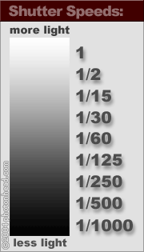 | 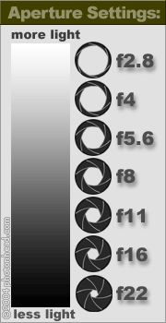 | On each line describe the situation in which you would use that setting, also describe the depth of field.
1 |  |  | 1.8
2 |  |  | 2.8
15 |  |  | 4
30 |  |  | 5.6
60 |  |  | 8
125 |  |  | 11
250 |  |  | 16
500 |  |  | 22
1000 |  |  | 32
What is this pointing to? 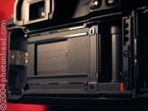 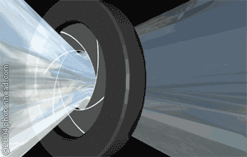What is this image depicting?
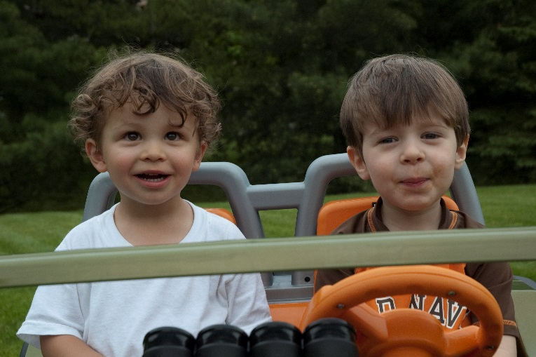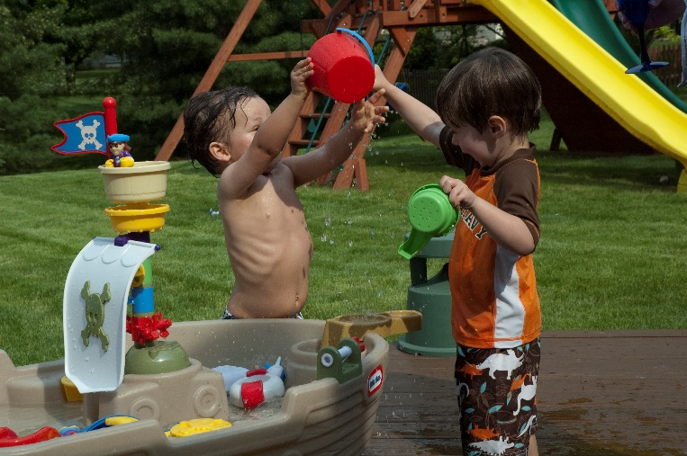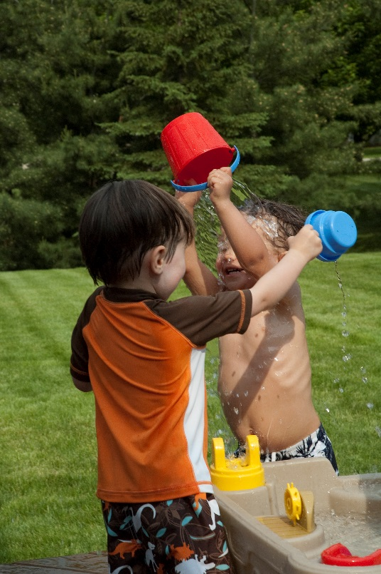
Which image below has a shallow depth of field? How did I do that?

What

Draw a line to the picture with these exposures: F11 sp 400 F 5.6 sp 125
How did you know the answer?

